***_______________________CRUD_JAVA k_4____________________________***

**Nama : Muhamad Wahyu Saputra**

**Kelas : XII RPL B**

**Absen : 34**

1. Buka source package membuatcrud mvcjava.Controller, Tuliskan syntax View_Member frame_member sebelum itu import beberapa class berikut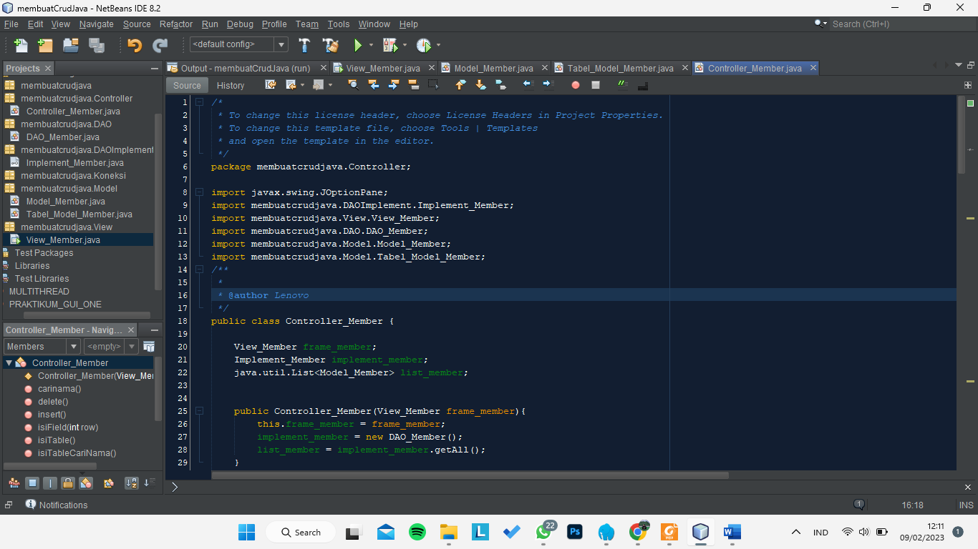
2. Tuliskan syntax View_Member frame_member  
   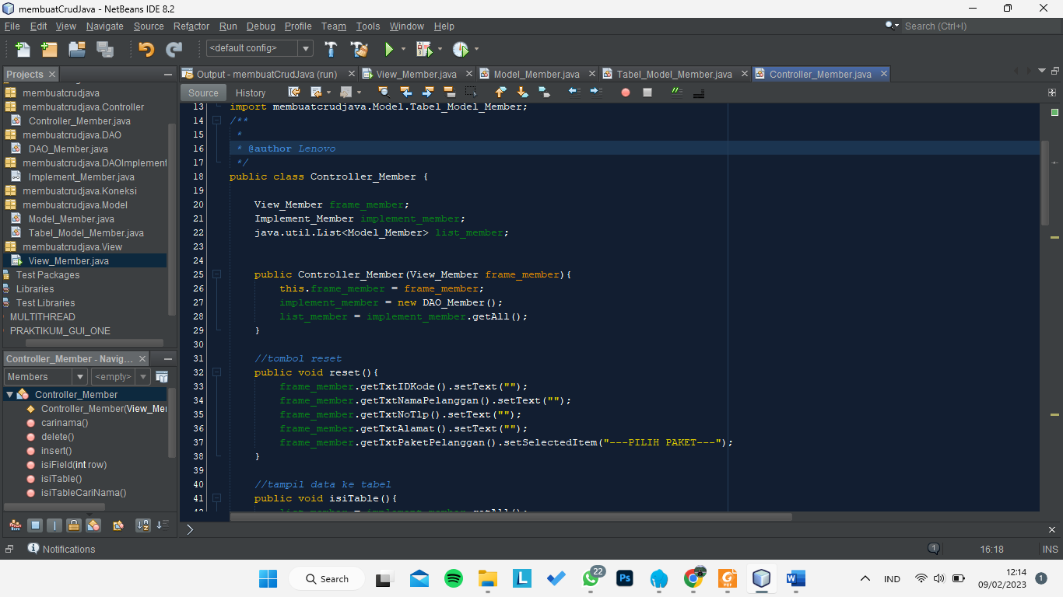
3. Tuliskan beberapa function[reset() & isitable() ] di class **controller_member**  
   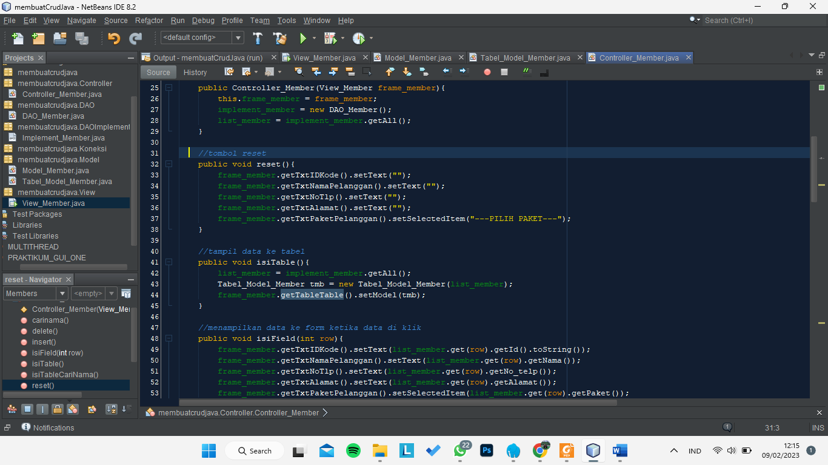
4. function[isifield() & insert()]  
   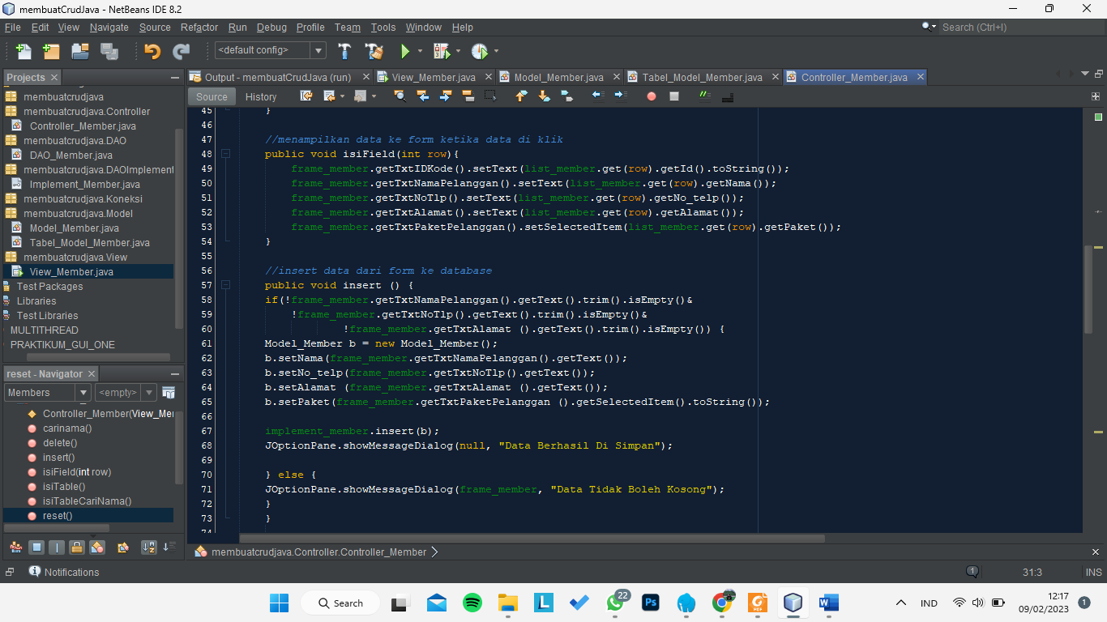
5. func update & delete  
   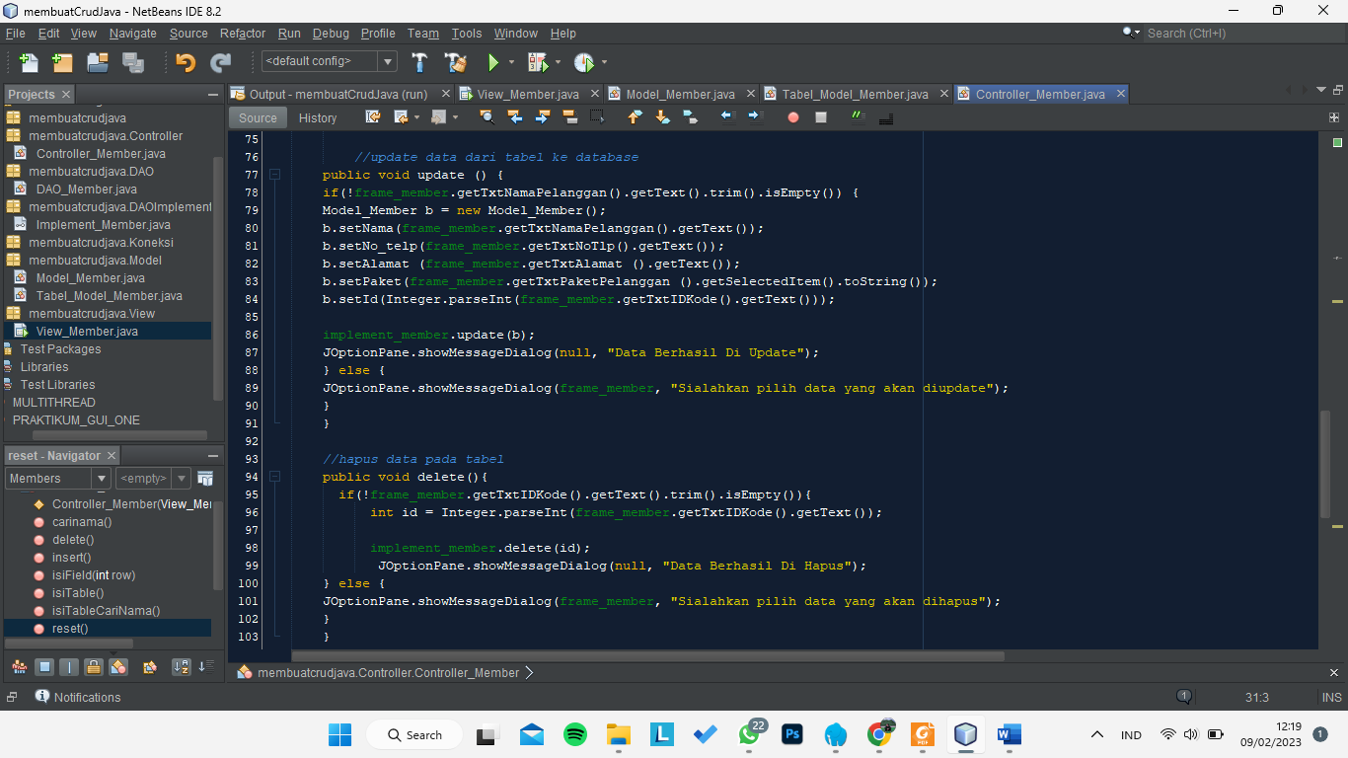
6. func cari data  
   